**WHY ANSIBLE:**

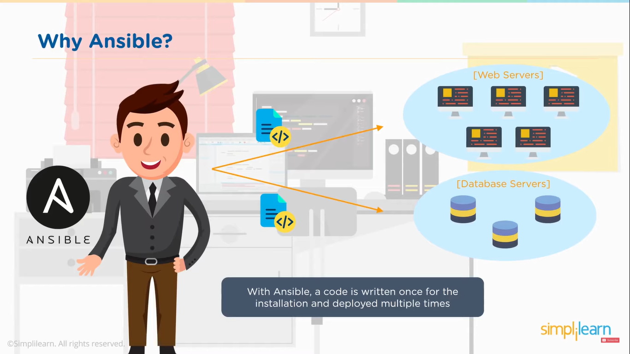

**WHAT IS ANSIBLE:**

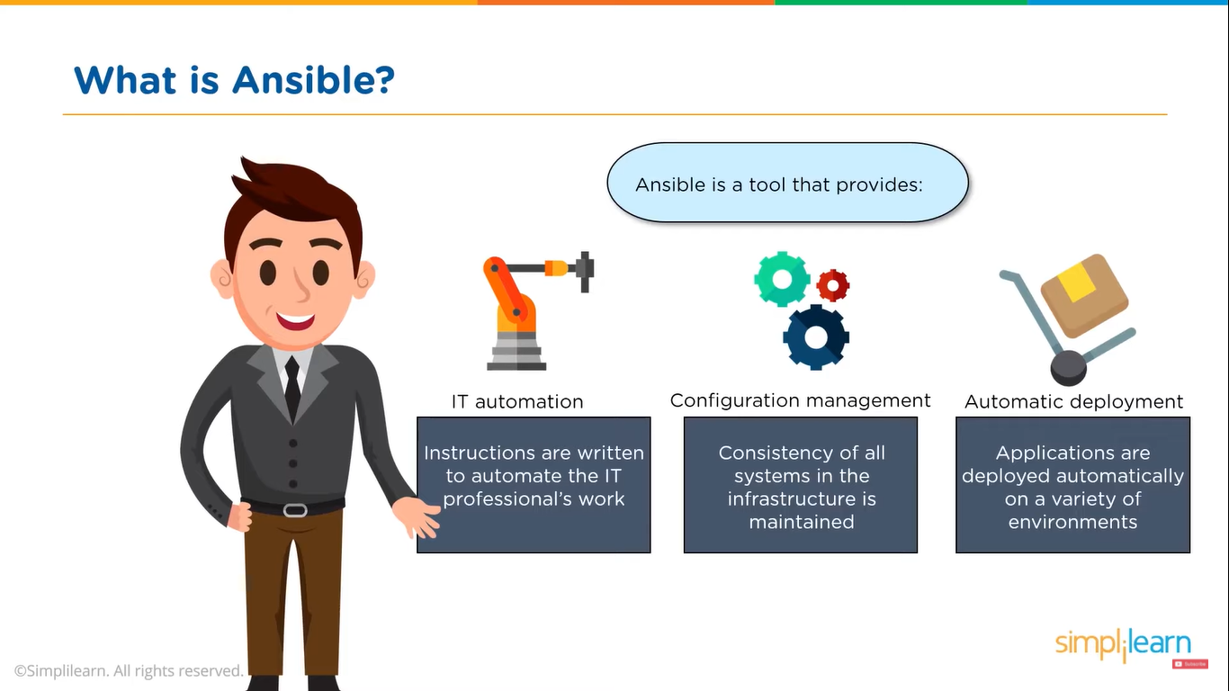

**PULL AND PUSH CONFIGURATION MODEL:**

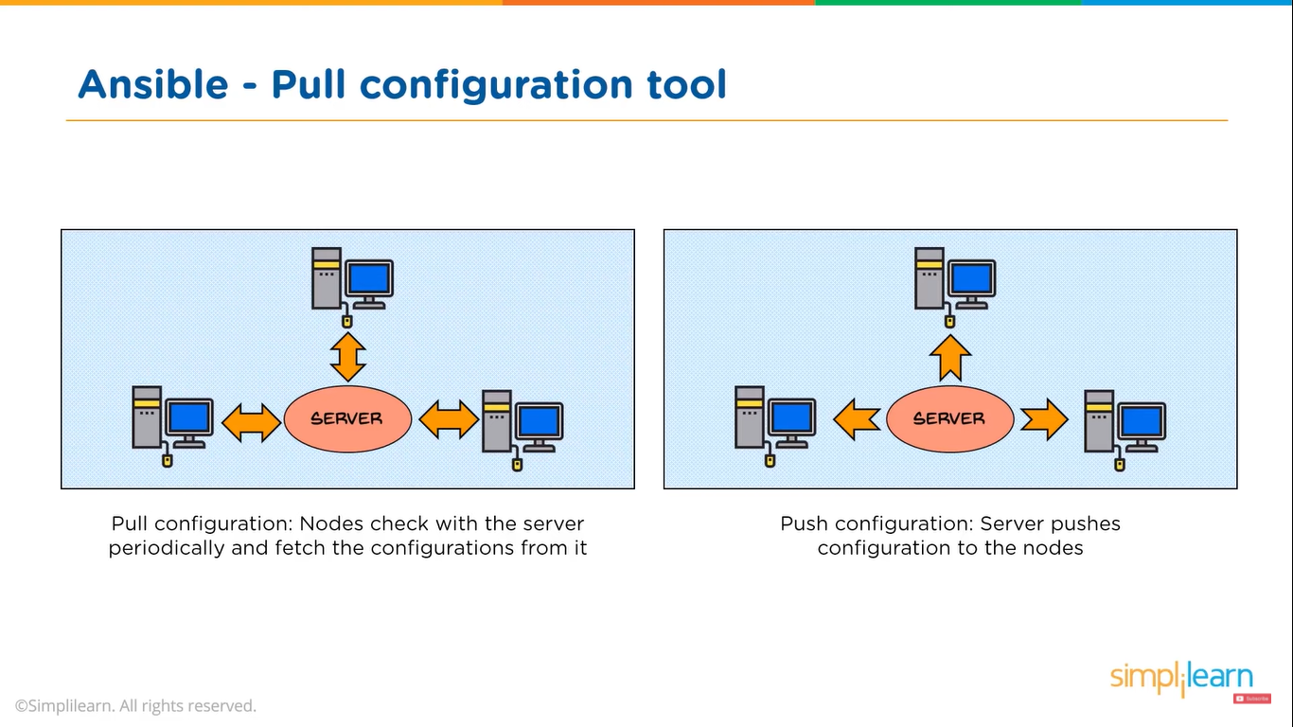

**ANSIBLE ARCHITECTURE:**

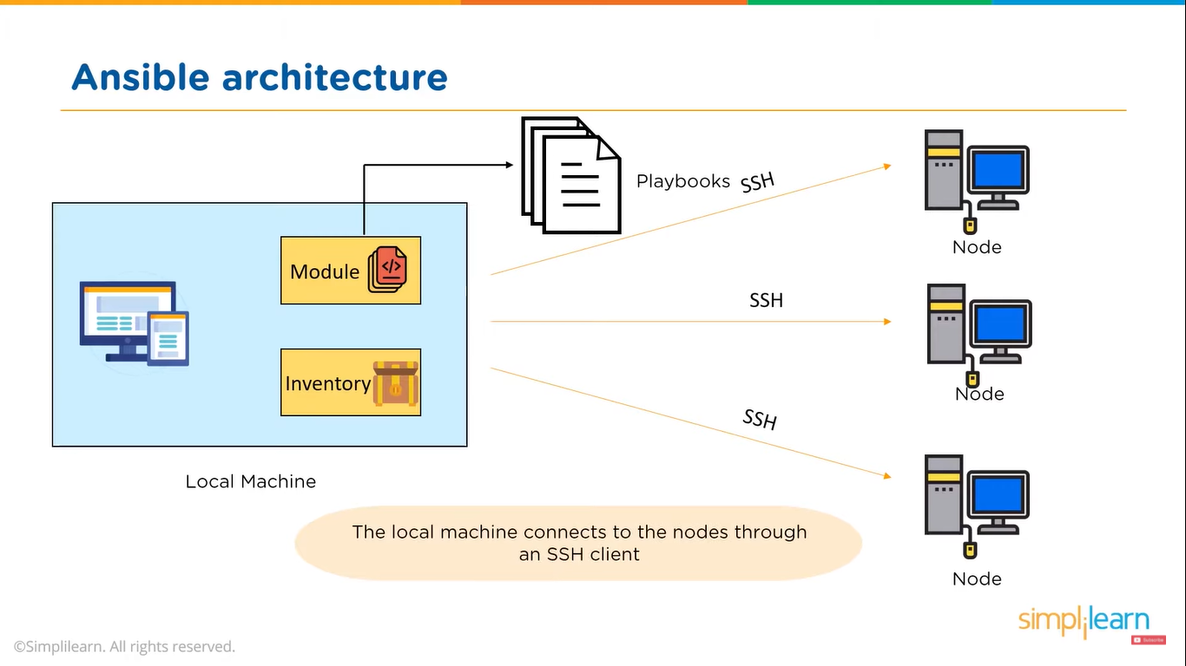

* **Local machine** is where Ansible is installed
* **Nodes** are the systems to be configured. They are controlled by the local machine.
* **Module** is the collection of configuration code files.
* These configuration code files are called as **Playbooks**
* **Inventory** is a document that groups the nodes under specific tables.
* Local machine connects to different nodes through an **SSH client**

**PLAYBOOKS:**

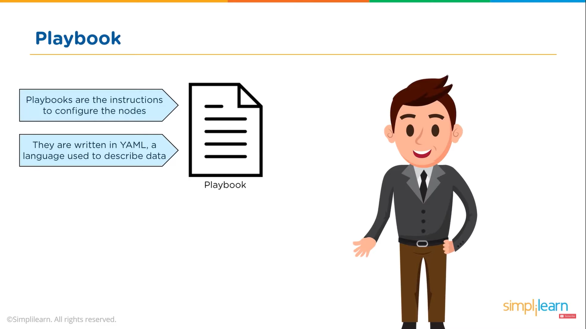

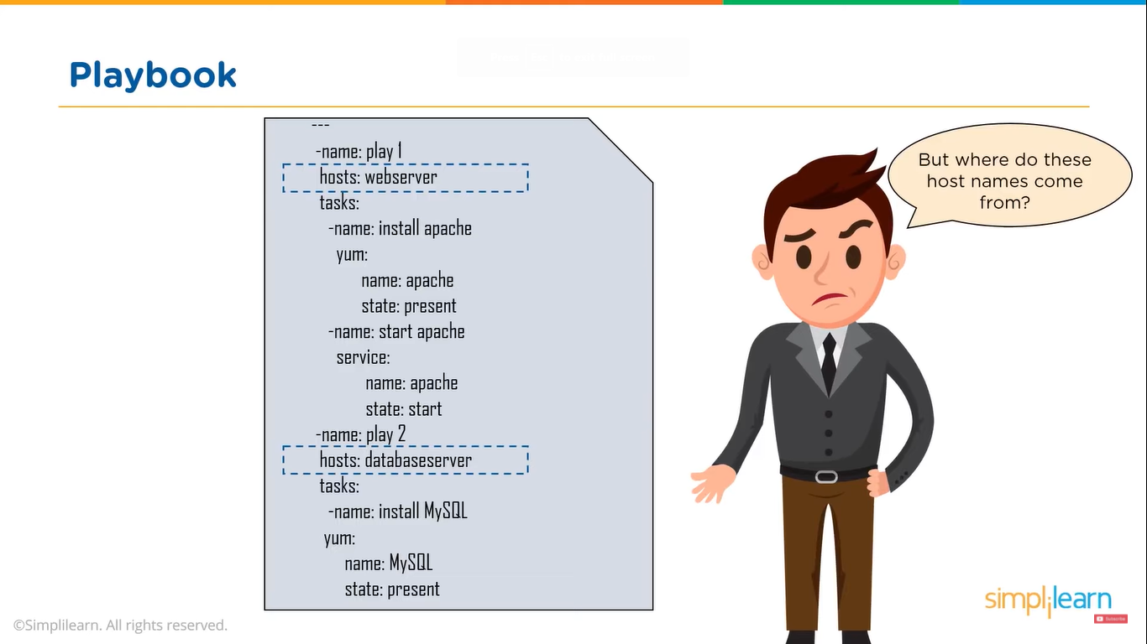

**INVENTORY:**

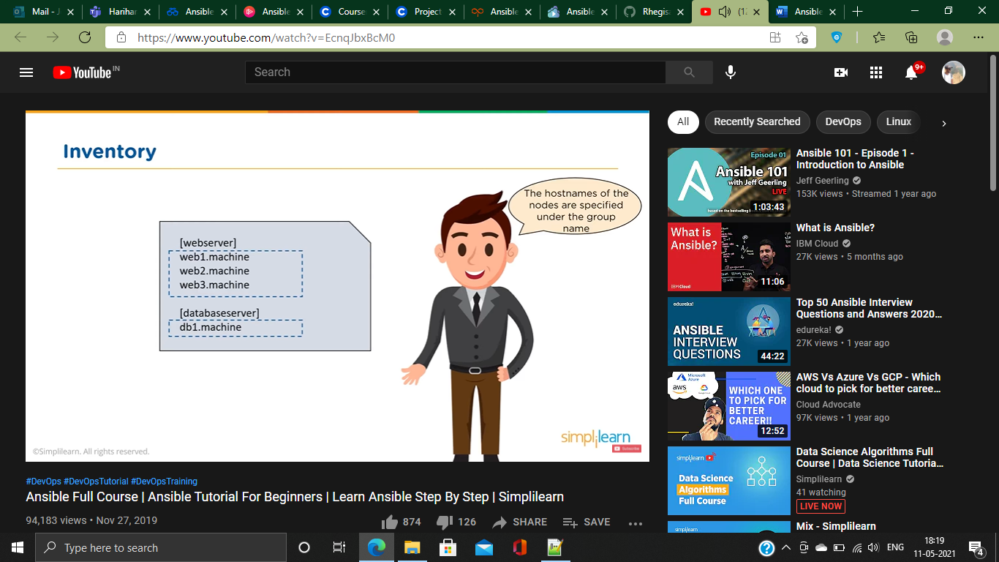

**WORKING OF ANSIBLE:**

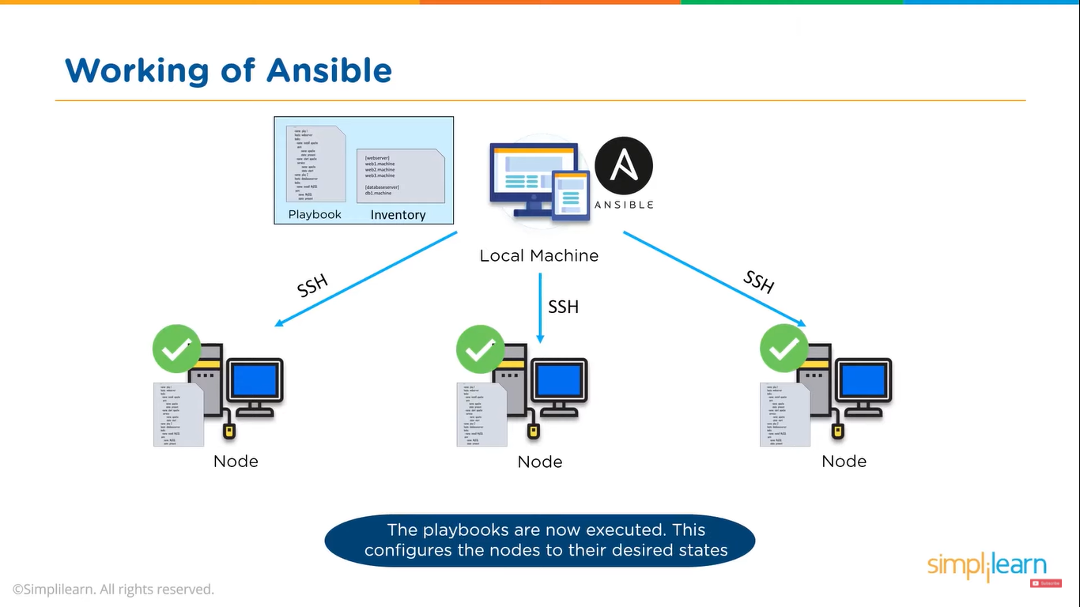

**ANSIBLE TOWER:**

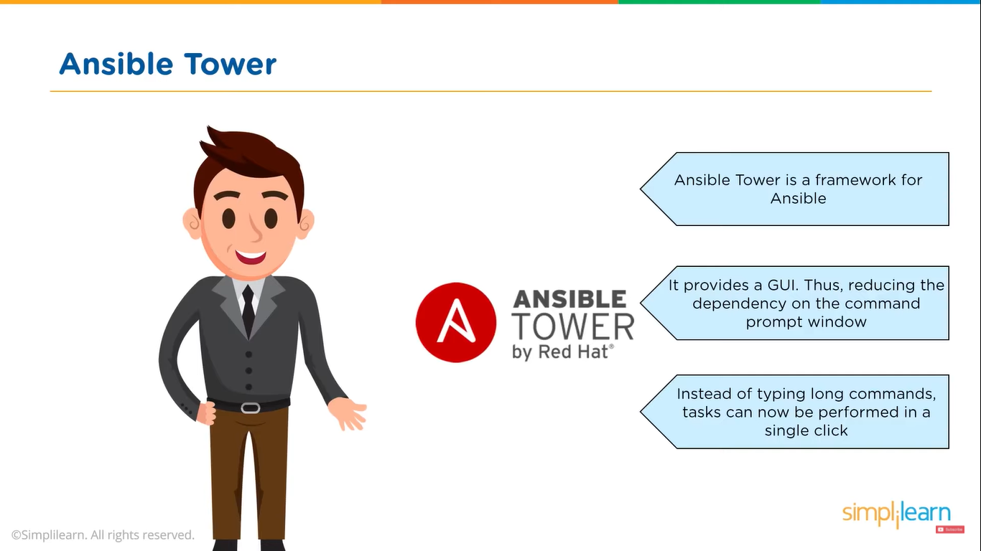

**BENEFITS OF ANSIBLE:**

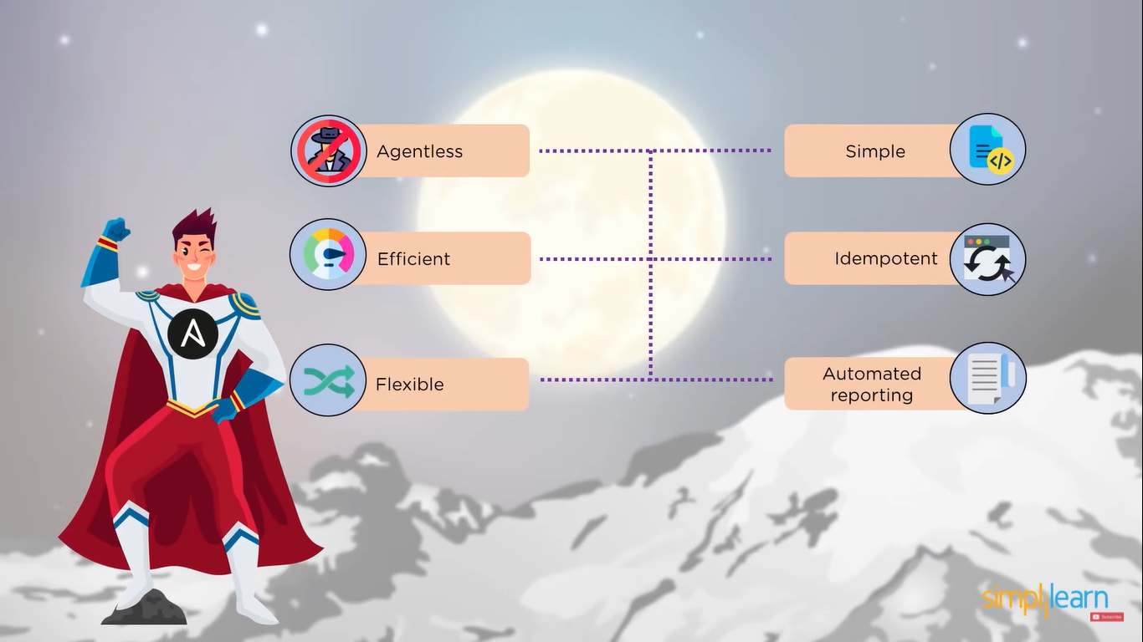

**DEMO:**

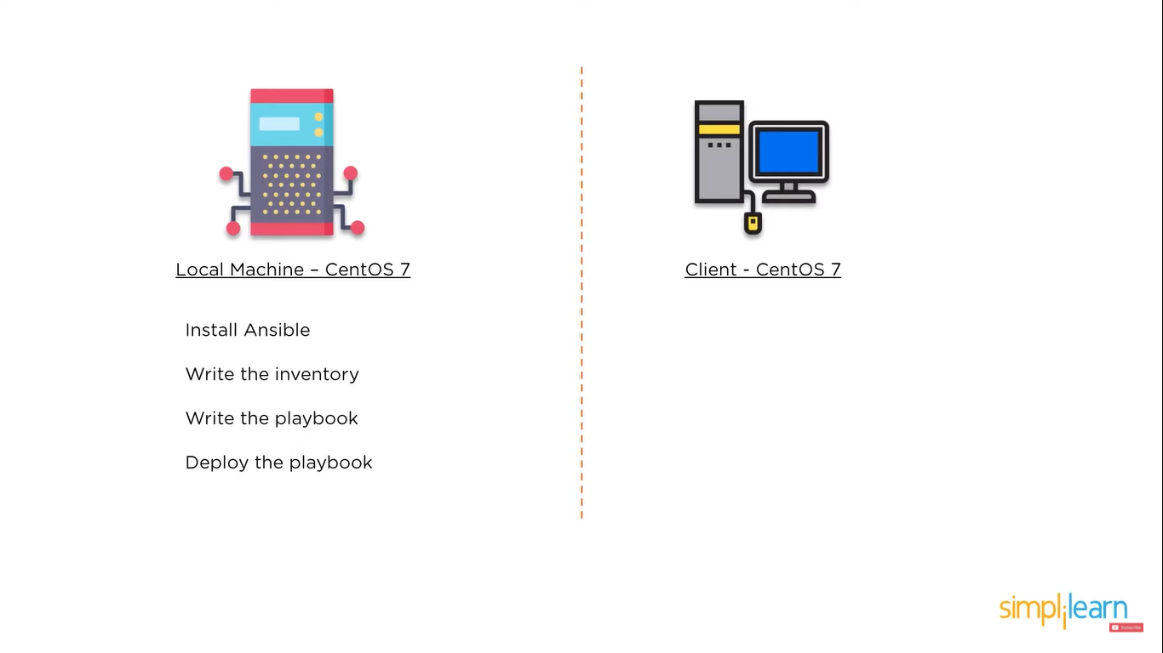

ansible-playbook -i inventory playbook.yml

